

OOP Lab #2
SUBMITTED BY:
UBAID AHMAD
ROLL NO:
2410-0011
SUBMITTED TO:
Mam Laiba Tanveer
DATE:
01/10/2025

Example code:
#include <iostream>
using namespace std;
struct employ{
string name;
string designation;
void read(){
cout<<" enter name: ";
getline(cin,name);
cout<<"enter designation: ";
getline(cin,designation);

}
void display(){
cout<<"Name is : "<<name<<endl;
cout<<"Designation is: "<<designation<<endl;
}
};
int main(){
employ e;
// e.name="Ubaid";
// e.designation="Student";
// cout<<"Name is: "<<e.name<<" \nDesignation is: "<<e.designation<<endl;

e.read();
e.display();
return 0;
}
OutPut
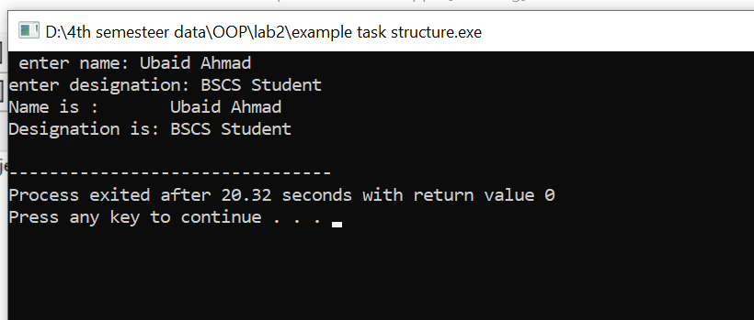

Task 1
Code:
#include <iostream>
using namespace std;
struct Student{
string name;
int rollNo;
string Uni_name;
int year;
string semester;
// function for reading student data
void read(){
cout<<"Enter Student Name: ";
getline(cin,name);
cout<<"Enter Student RollNo: ";
cin>>rollNo;
cout<<"Enter University Name: ";
cin.ignore();
getline(cin,Uni_name);
cout<<"Enter admission year: ";
cin>>year;
cout<<"Enter current Semester: ";
cin.ignore();
getline(cin,semester);
}
void display(){
cout<<"Student Name is: "<<name<<endl;
cout<<"Student RollNo is: "<<rollNo<<endl;
cout<<"University Name is: "<<Uni_name<<endl;
cout<<"Admission Year is: "<<year<<endl;
cout<<"Current semester is: "<<semester<<endl;

}
};
int main(){
Student s1,s2;
cout<<"----------------------------------Enter data for student 1!\n"<<endl;
s1.read();
cout<<"----------------------------------Enter data for student 2!\n"<<endl;
s2.read();

cout<<"\n--------------------------------displaying data for student 1!\n"<<endl;
s1.display();
cout<<"--------------------------------displaying data for student 2!"<<endl;
s2.display();
return 0;
}
OUtPut
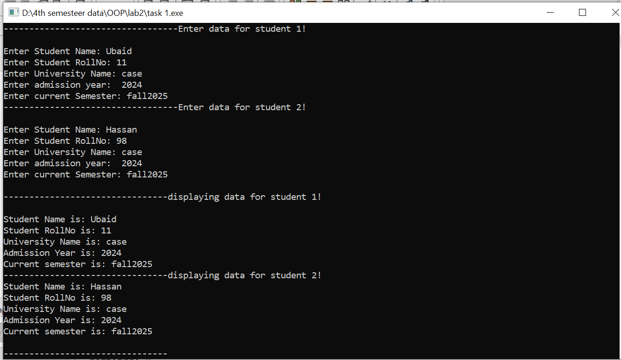

Task2
Code:
#include <iostream>
using namespace std;
struct Fruit{
string name;
int price;
int quantity;

void getData(string n,int p,int q){
this->name=n;
this->price=p;
this->quantity=q;
}

int totalAmount(){
int total;
total=this->price*this->quantity;
return total;
}

};
int GrndTotal(Fruit f1,Fruit f2,Fruit f3,Fruit f4,Fruit f5)
{
int x;
x=f1.totalAmount()+f2.totalAmount()+f3.totalAmount()+f4.totalAmount
()+f5.totalAmount();
return x;
}
int main(){
Fruit f1,f2,f3,f4,f5;
f1.getData("orange",10,12);
f2.getData("apple",20,15);
f3.getData("banana",15,30);
f4.getData("peach",20,40);
f5.getData("nashpati",30,50);
// totals for each
cout<<"----------------Total amounts for each fruit are: "<<endl;
cout<<"for orange: "<<f1.totalAmount()<<endl;
cout<<"for apple: "<<f2.totalAmount()<<endl;
cout<<"for banana: "<<f3.totalAmount()<<endl;
cout<<"for peach: "<<f4.totalAmount()<<endl;
cout<<"for nashpati: "<<f5.totalAmount()<<endl;

cout<<" ------------------------------Grand total for all the fruits!"<<endl;
int Grand_total=GrndTotal(f1,f2,f3,f4,f5);
cout<<"Grand Total is: "<<Grand_total<<endl;
return 0;

}
OutPut: 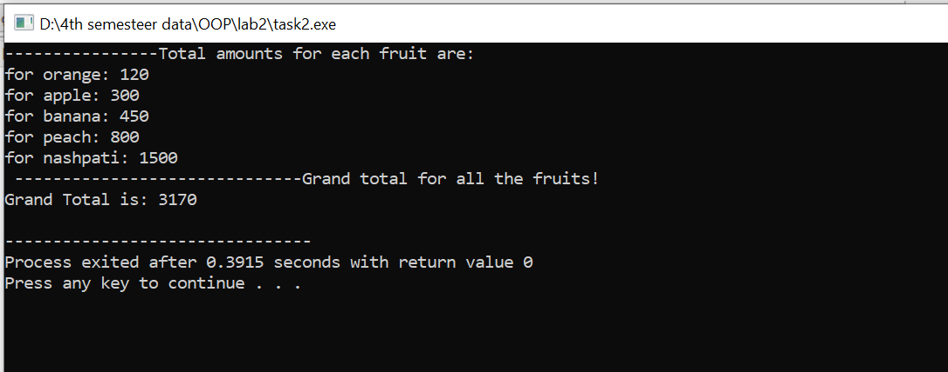

Task3
Code:
#include <iostream>
using namespace std;

struct item{
int code;
string name;
int price;
int quantity;
void read(){
cout<<"Enter item code: ";
cin>>this->code;
cout<<"Enter item name: ";
cin>>this->name;
cout<<"Enter item price: ";
cin>>this->price;
cout<<"Enter item Quantity: ";
cin>>this->quantity;
}
};

int main(){
int size=5;
item o[size]; //array of 5 objects
for(int i=0;i<size;i++){
cout<<"\n---------------enter data for student: "<<i+1<<endl;
o[i].read();
}
//total cast
int total_value=0;
for(int i=0;i<size;i++){
int x=o[i].price*o[i].quantity;
total_value+=x;
}
cout<<"Total cast is: "<<total_value<<endl;
return 0;
}
OutPut

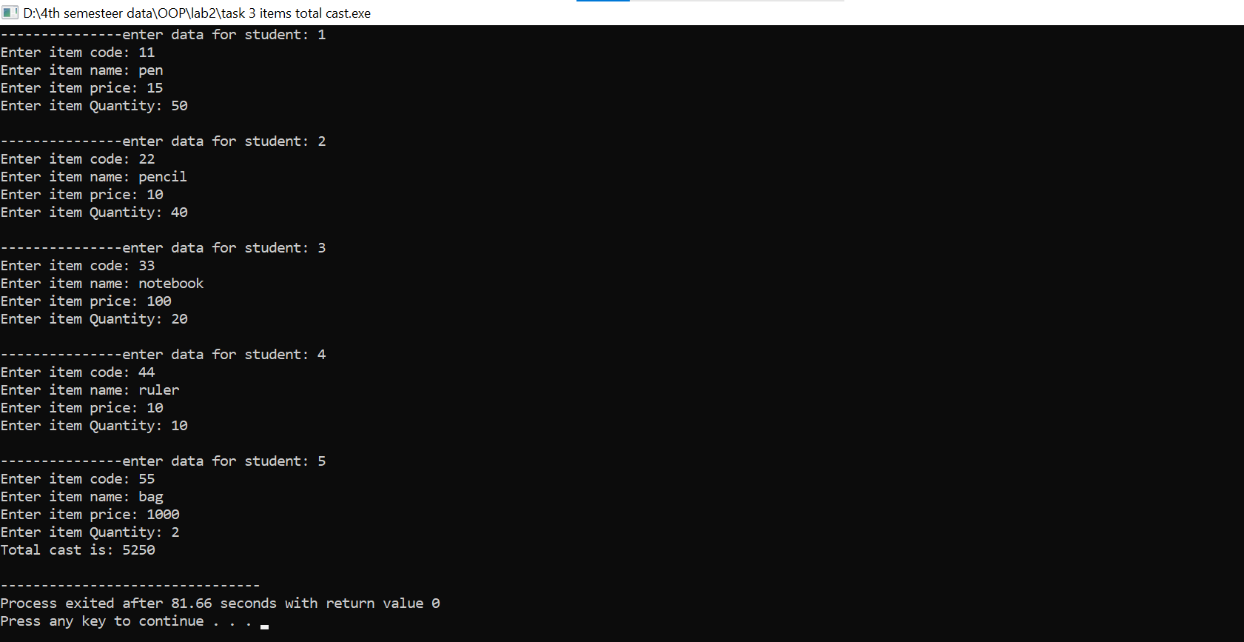

Task4
Code:
#include <iostream>
using namespace std;
const int SIZE = 5;
// Structure for Course
struct Course {
int course_id;
string course_title;
float credit_hrs;
};

void addACourse(Course courses[], int &count) {
if (count >= SIZE) {
cout << "Cannot add more courses. Array is full!\n";
return;
}
cout << "Enter course ID: ";
cin >> courses[count].course_id;
cout << "Enter course title: ";
cin.ignore();
getline(cin, courses[count].course_title);
cout << "Enter credit hours: ";
cin >> courses[count].credit_hrs;

count++;
cout << "Course added successfully!\n";
}

void updateCourse(Course courses[], int count) {
int id;
cout << "Enter course ID to update: ";
cin >> id;

for (int i = 0; i < count; i++) {
if (courses[i].course_id == id) {
cout << "Enter new title: ";
cin.ignore();
getline(cin, courses[i].course_title);
cout << "Enter new credit hours: ";
cin >> courses[i].credit_hrs;
cout << "Course updated successfully!\n";
return;
}
}
cout << "Course not found!\n";
}

void deleteCourse(Course courses[], int &count) {
int id;
cout << "Enter course ID to delete: ";
cin >> id;

for (int i = 0; i < count; i++) {
if (courses[i].course_id == id) {
for (int j = i; j < count - 1; j++) {
courses[j] = courses[j + 1];
}
count--;
cout << "Course deleted successfully!\n";
return;
}
}
cout << "Course not found!\n";
}

void searchAndDisplayCourse(Course courses[], int count) {
int id;
cout << "Enter course ID to search: ";
cin >> id;

for (int i = 0; i < count; i++) {
if (courses[i].course_id == id) {
cout << "Course found!\n";
cout << "ID: " << courses[i].course_id
<< ", Title: " << courses[i].course_title
<< ", Credit Hours: " << courses[i].credit_hrs << endl;
return;
}
}
cout << "Course not found!\n";
}

void displayAllCourses(Course courses[], int count) {
if (count == 0) {
cout << "No courses available!\n";
return;
}
cout << "All Courses:\n";
for (int i = 0; i < count; i++) {
cout << "ID: " << courses[i].course_id
<< ", Title: " << courses[i].course_title
<< ", Credit Hours: " << courses[i].credit_hrs << endl;
}
}

int main() {
Course courses[SIZE];
int count = 0;
char option;

do {
cout << "\nMain Menu:\n";
cout << "Press 1 to add a Course\n";
cout << "Press 2 to update a Course\n";
cout << "Press 3 to delete a Course\n";
cout << "Press 4 to search and display a Course\n";
cout << "Press 5 to display all Courses\n";
cout << "Press e to exit the program\n";
cout << "Enter option: ";
cin >> option;

switch (option) {
case '1': addACourse(courses, count); break;
case '2': updateCourse(courses, count); break;
case '3': deleteCourse(courses, count); break;
case '4': searchAndDisplayCourse(courses, count); break;
case '5': displayAllCourses(courses, count); break;
case 'e': cout << "Exiting program...\n"; break;
default: cout << "Invalid option! Try again.\n";
}
} while (option != 'e');

return 0;
}
OutPut:
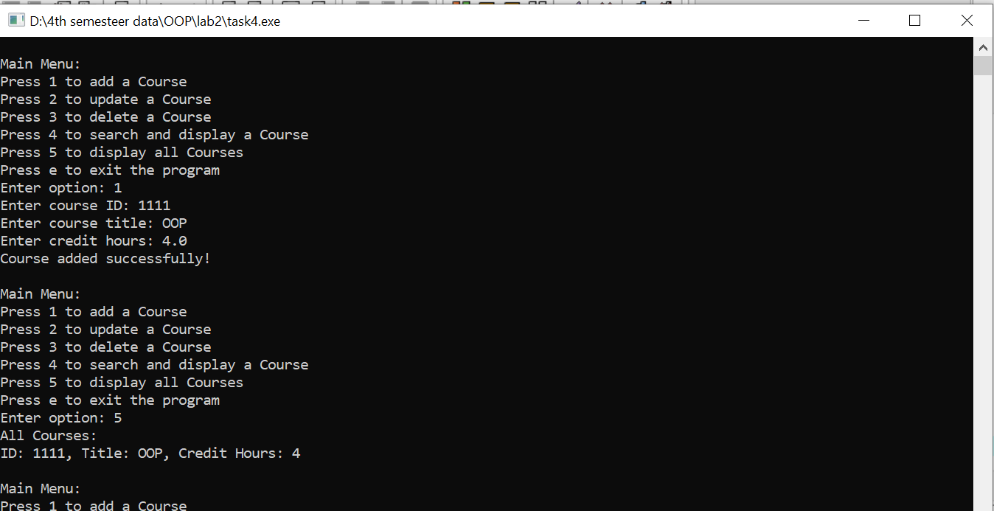
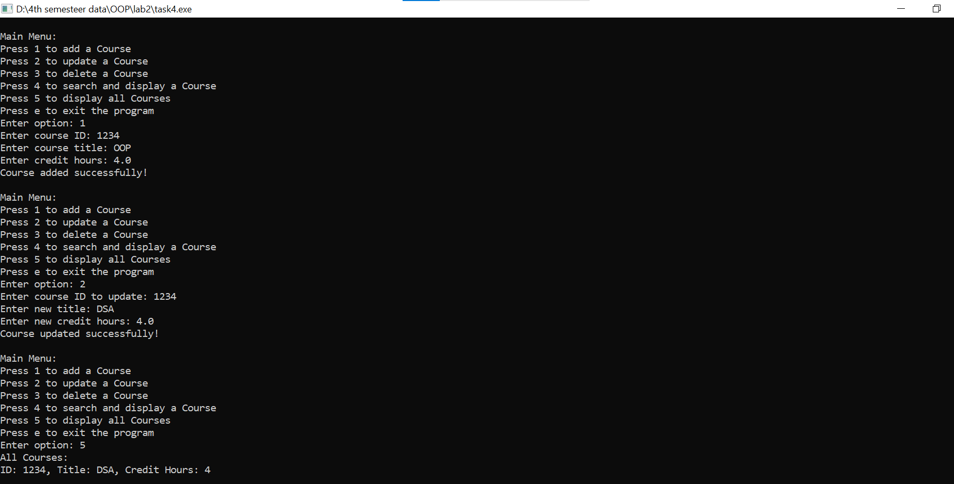
Task5
Code:
#include <iostream>
using namespace std;
struct android{
long long int IMEIno;
string type;
string make;
int modelno;
float memory;
string Operating_system;
//passing default values
// android(){
// this->IMOIno=1120;
// this->type="smartphone";
// this->make="samsung";
// this->memory=128.00;
// this->Operating_system="android";
// this->modelno=12;
// }

void setValues(){
cout<<"Enter IMEI Number: ";
cin>>this->IMEIno;
cout<<"Enter Type : ";
cin>>this->type;
cout<<"Enter make : ";
cin>>this->make;
cout<<"enter memory: ";
cin>>this->memory;
cout<<"Enter operating System: ";
cin>>this->Operating_system;

}
void display(){
cout<<"IMEI number : "<<this->IMEIno<<endl;
cout<<"type is : "<<this->type<<endl;
cout<<"make is : "<<this->make<<endl;
cout<<"memory is : "<<this->memory<<endl;
cout<<"OS is : "<<this->Operating_system<<endl;
cout<<"modelNo is : "<<this->modelno<<endl;
}
};
int main()
{
android a;
cout<<"----------------------setting values--------------\n"<<endl;
a.setValues();
cout<<"\n----------------------displaying Data-------------\n"<<endl;
a.display();
return 0;
}
Output:
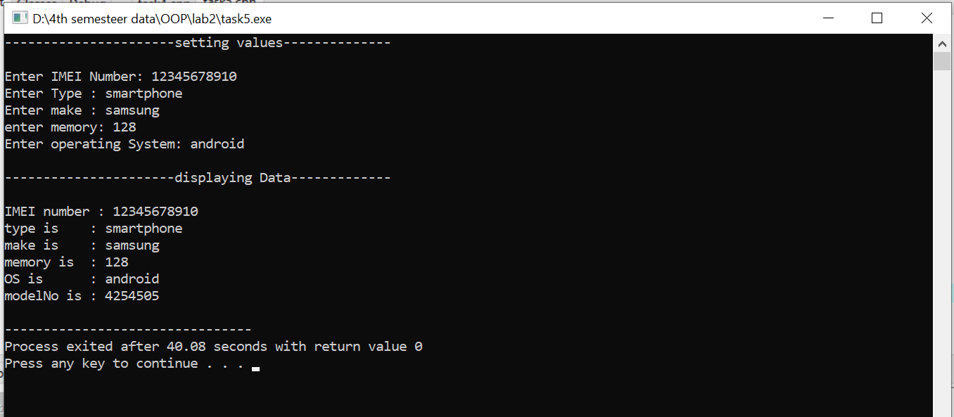

End,,,

